 | ภาควิชาวิศวกรรมคอมพิวเตอร์ คณะวิศวกรรมศาสตร์  มหาวิทยาลัยเทคโนโลยีราชมงคลธัญบุรี | รหัสวิชา 04-624-201  ชื่อวิชา Machine Learning
ชื่อ นายสิทธิกร บุญณะ รหัสนักศึกษา 116630462039-4 กลุ่ม 1

ใบงานที่ 1 Support Vector Machine
และการประยุกต์ใช้งาน SVM
วัตถุประสงค์
- เพื่อให้นักศึกษาเข้าใจหลักการทำงานของ Support Vector Machine (SVM) และแนวทางการประยุกต์ใช้ในงานจริงทั้งด้านการจำแนกและการพยากรณ์
- เพื่อให้นักศึกษาสามารถพัฒนาผังการทำงาน ประมวลผล และแสดงผลลัพธ์ เพื่อพัฒนาระบบต้นแบบร่วมกับ SVM ในการจำแนกและการพยากรณ์ได้อย่างถูกต้อง
LEB 1: SVM on the Iris Dataset (Multiclass Classification)
Objective:
- Apply Support Vector Machine (SVM) to classify Iris flower specie.
- Compare the performance of different SVM kernels
Contents:
- Load the Iris dataset from sklearn.datasets (datasets.load_iris()).
- Split the data into training and testing sets.
- Train SVM models using three kernels: (Linear, Polynomial, RBF)
- Evaluate each model using accuracy.
Output:
Accuracy scores for each SVM kernel.

Code:  from sklearn import datasets  from sklearn.model_selection import train_test_split  from sklearn.svm import SVC  from sklearn.metrics import accuracy_score  iris = datasets.load_iris()  X = iris.data; y = iris.target  X_train, X_test, y_train, y_test = \  train_test_split(X, y, test_size=0.2, random_state=100)  kernels = ['linear', 'poly', 'rbf']  for k in kernels:  model = SVC(kernel=k, C=1.0, random_state=100)  model.fit(X_train, y_train)  y_pred = model.predict(X_test)  acc = accuracy_score(y_test, y_pred)  print(f"Kernel = {k:<6}: Accuracy = {acc:.2f}")  print("-" * 40) | Flowchart:  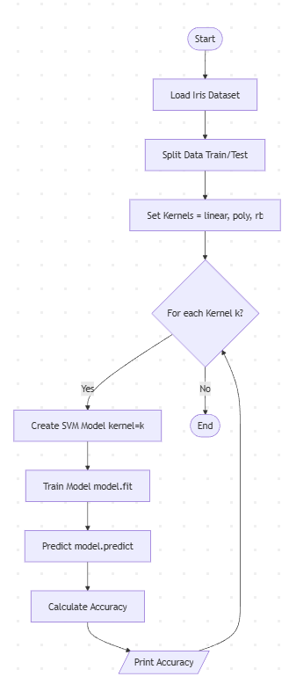
Result:

Kernel = linear: Accuracy = 1.00
Kernel = poly : Accuracy = 0.97
Kernel = rbf : Accuracy = 1.00

LEB 2: SVM on the Iris Dataset (.CSV)
Link: https://www.kaggle.com/datasets/saurabh00007/iriscsv
Objective:
- Apply Support Vector Machine (SVM) to classify Iris flower specie.
- Compare the performance of different SVM kernels
Contents:
- Load the Iris dataset from directory (Link).
- Split the data into training and testing sets.
- Train SVM models using three kernels: (Linear, Polynomial, RBF)
- Evaluate each model using accuracy.
Output:
Accuracy scores for each SVM kernel.

Code:  import pandas as pd  from sklearn.model_selection import train_test_split  from sklearn.svm import SVC  from sklearn.metrics import accuracy_score  # Load data from CSV  # CSV: sepal_length, sepal_width, petal_length,\  # petal_width, species  df = pd.read_csv(r"D:\code\project_\iris.csv")  print(df.head())  # Features and target  X = df.iloc[:, :-1].values  # all columns except last one  y = df.iloc[:, -1].values # last column is label  # 2. Split train/test  X_train, X_test, y_train, y_test = train_test_split(  X, y, test_size=0.2, random_state=42)  # Compare kernels  kernels = ['linear', 'poly', 'rbf']  for k in kernels:  model = SVC(kernel=k, C=1.0, random_state=42)  model.fit(X_train, y_train)  y_pred = model.predict(X_test)  acc = accuracy_score(y_test, y_pred) * 100  print(f"Kernel = {k:<6}: Accuracy = {acc:.2f}%") | Flowchart:  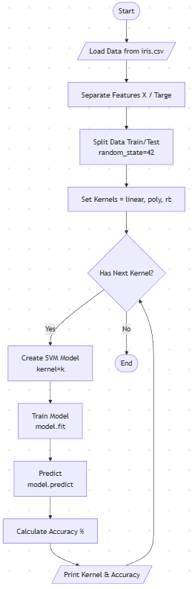
Result:

Kernel = linear: Accuracy = 100.00%
Kernel = poly : Accuracy = 100.00%
Kernel = rbf : Accuracy = 100.00%

LEB 3: SVM flower image classification and dataset directory path. (Ex.3)
Link: https://www.kaggle.com/datasets/jeffheaton/iris-computer-vision
Output:
- Classification accuracy on the test set.
- A row of sample test images showing:
- “True: … / Pred: …”
- Correct predictions in green.

Code:  import os  import cv2  import numpy as np  import matplotlib.pyplot as plt  from sklearn.model_selection import train_test_split  from sklearn.svm import SVC  from sklearn.metrics import accuracy_score  dataset_path = r"C:\Users\YH\Downloads"  IMG_SIZE = 64  image_size = (IMG_SIZE, IMG_SIZE)  X = []  y = []  if not os.path.exists(dataset_path):  print(f"Error: Path not found: {dataset_path}")  print("Please download dataset from Kaggle and set the correct path.")  else:  classes = ['iris-setosa', 'iris-versicolor', 'iris-virginica']  for category in classes:  path = os.path.join(dataset_path, category)  if not os.path.isdir(path):  continue  for img_name in os.listdir(path):  try:  img_path = os.path.join(path, img_name)  img_array = cv2.imread(img_path, cv2.IMREAD_GRAYSCALE)  if img_array is None:  continue  for img_name in os.listdir(path):  try:  img_path = os.path.join(path, img_name)  img_array = cv2.imread(img_path, cv2.IMREAD_GRAYSCALE)  if img_array is None:  continue  new_array = cv2.resize(img_array, image_size)  X.append(new_array.flatten())  y.append(category)  except Exception as e:  pass  X = np.array(X)  y = np.array(y)  if len(X) > 0:  X_train, X_test, y_train, y_test = train_test_split(  X, y, test_size=0.2, random_state=42)  model = SVC(kernel='linear', C=1.0, random_state=42)  model.fit(X_train, y_train)  y_pred = model.predict(X_test)  acc = accuracy_score(y_test, y_pred) * 100  print(f"Model Accuracy on Test Set: {acc:.2f}%")  plt.figure(figsize=(12, 3))  num_samples = min(5, len(X_test))  for i in range(num_samples):  idx = i  plt.subplot(1, 5, i+1)  plt.imshow(X_test[idx].reshape(image_size), cmap='gray')  true_label = y_test[idx]  pred_label = y_pred[idx]  color = 'green' if true_label == pred_label else 'red'  plt.title(f"True: {true_label}\nPred: {pred_label}", color=color, fontsize=10)  plt.axis('off')  plt.tight_layout()  plt.show()  else:  print("No images found. Please check dataset path.") | Flowchart:  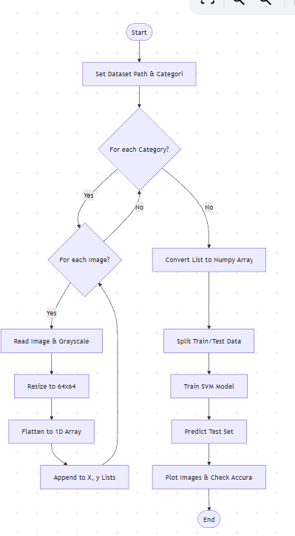
Result:

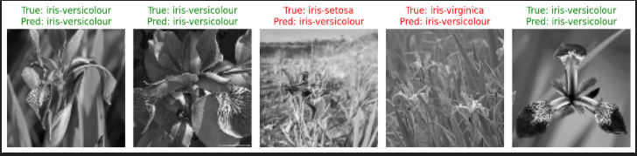

LEB 4: SVM on Protozoan Parasite Image Data (PPID) (contains microscopic images)
Link: https://www.kaggle.com/datasets/ankushmallick/protozoan-parasite-image-dataset
Objective:
- Apply SVM to PPID classify.
Contents:
- Load a dataset.
- Load the PPID dataset from directory (Link).
- Split the data into training and testing sets.
- Train SVM models using three kernels: (Linear, Polynomial, RBF)
- Evaluate each model using accuracy.
Output:
- Classification accuracy on the test set.
- A row of sample test images showing:
- “True: … / Pred: …”
- Correct predictions in green.
- Confusion matrix

Code or Algorithms:  import os  import cv2  import numpy as np  import matplotlib.pyplot as plt  from sklearn.model_selection import train_test_split  from sklearn.svm import SVC  from sklearn.metrics import accuracy_score, confusion_matrix, ConfusionMatrixDisplay  dataset_path = r"C:\Users\YH\Downloads\Dataset"  IMG_SIZE = 64  image_size = (IMG_SIZE, IMG_SIZE)  def load_data(path):  x_data = []  y_data = []  if not os.path.exists(path):  print(f"Error: ไม่พบโฟลเดอร์ {path}")  return np.array([]), np.array([])  print("กำลังโหลดรูปภาพ")  classes = [d for d in os.listdir(path) if os.path.isdir(os.path.join(path, d))]  for category in classes:  folder_path = os.path.join(path, category)  print(f" - กำลังอ่าน Class: {category}")  for img_name in os.listdir(folder_path):  try:  img_path = os.path.join(folder_path, img_name)  img_array = cv2.imread(img_path, cv2.IMREAD_GRAYSCALE)  if img_array is None: continue  new_array = cv2.resize(img_array, image_size)  # Flatten  x_data.append(new_array.flatten())  y_data.append(category)  except Exception:  pass  return np.array(x_data), np.array(y_data)  X, y = load_data(dataset_path)  if len(X) > 0:  print(f"โหลดเสร็จสิ้น! จำนวนรูปภาพทั้งหมด: {len(X)}")  X = X / 255.0  X_train, X_test, y_train, y_test = train_test_split(X, y, test_size=0.2, random_state=42)  kernels = ['linear', 'poly', 'rbf']  best_model = None  best_acc = 0  best_k_name = ""  print("\nเริ่มการ Training SVM...")  for k in kernels:  model = SVC(kernel=k, C=1.0, random_state=42)  model.fit(X_train, y_train)  y_pred = model.predict(X_test)  acc = accuracy_score(y_test, y_pred) * 100  print(f" Kernel = {k:<6}: Accuracy = {acc:.2f}%")  if acc > best_acc:  best_acc = acc  best_model = model  best_k_name = k  print(f"\nเลือกโมเดลที่ดีที่สุด: {best_k_name} ({best_acc:.2f}%)")  y_pred_best = best_model.predict(X_test)  plt.figure(figsize=(12, 4))  num_samples = min(5, len(X_test))  for i in range(num_samples):  plt.subplot(1, 5, i+1) # แก้จาก 6 เป็น 5 ให้พอดีช่อง  plt.imshow(X_test[i].reshape(image_size), cmap='gray')  true_lb = y_test[i]  pred_lb = y_pred_best[i]  col = 'green' if true_lb == pred_lb else 'red'  plt.title(f"T:{true_lb[:5]}..\nP:{pred_lb[:5]}..", color=col, fontsize=10)  plt.axis('off')  plt.suptitle(f"Prediction Sample (Best Kernel: {best_k_name})")  plt.tight_layout()  plt.show()  print("กำลังแสดง Confusion Matrix...")  cm = confusion_matrix(y_test, y_pred_best, labels=best_model.classes_)  disp = ConfusionMatrixDisplay(confusion_matrix=cm, display_labels=best_model.classes_)  fig, ax = plt.subplots(figsize=(10, 10))  disp.plot(cmap=plt.cm.Blues, ax=ax, values_format='d', xticks_rotation='vertical')  plt.title(f"Confusion Matrix ({best_k_name})")  plt.show()  else:  print("ไม่พบข้อมูลรูปภาพ กรุณาตรวจสอบ Path") | Flowchart:  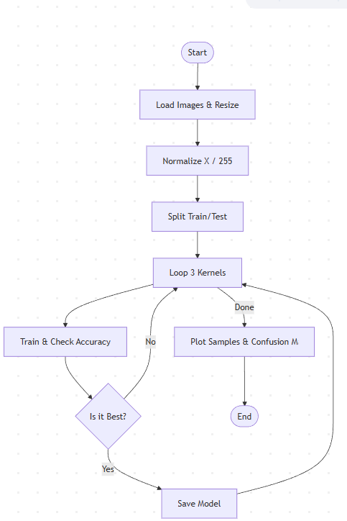
Result:

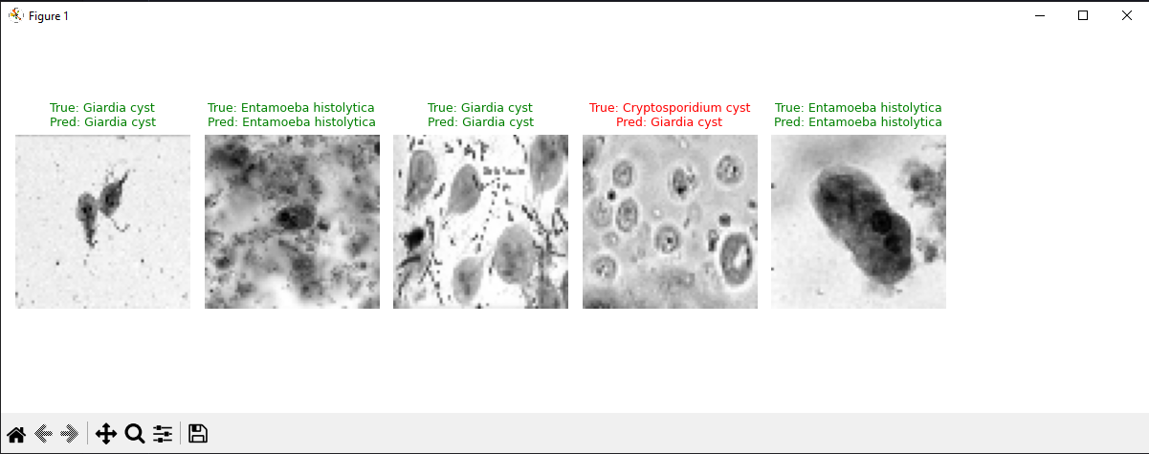

LEB 5: SVM on Blood Cells (microscopic peripheral blood cell images)
Link: https://www.kaggle.com/datasets/unclesamulus/blood-cells-image-dataset
Objective:
- Apply SVM to Blood Cells classify.
Contents:
- Load the Blood Cells dataset from directory (Link).
- Split the data into training and testing sets.
- Train SVM models using three kernels: (Linear, Polynomial, RBF)
- Evaluate each model using accuracy.
Output:
- Classification accuracy on the test set.
- A row of sample test images showing:
- “True: … / Pred: …”
- Correct predictions in green.
- Confusion matrix

Code or Algorithms:  import os  import cv2  import numpy as np  import matplotlib.pyplot as plt  from sklearn.model_selection import train_test_split  from sklearn.svm import SVC  from sklearn.metrics import accuracy_score, confusion_matrix, ConfusionMatrixDisplay  print("1. Configuration & Data Loading...")  base_path = r"C:\Users\YH\Downloads"  IMG_SIZE = 64  image_size = (IMG_SIZE, IMG_SIZE)  TARGET_CLASSES = ['EOSINOPHIL', 'LYMPHOCYTE', 'MONOCYTE', 'NEUTROPHIL']  def find_and_load_data(root_path, target_classes):  x_data = []  y_data = []  found_classes = set()  print(f"Searching for data in: {root_path} ...")  for root, dirs, files in os.walk(root_path):  for dir_name in dirs:  if dir_name.upper() in target_classes:  print(f" -> Found folder: {dir_name}. Loading images...")  found_classes.add(dir_name.upper())  folder_path = os.path.join(root, dir_name)  for img_name in os.listdir(folder_path):  if not img_name.lower().endswith(('.png', '.jpg', '.jpeg', '.bmp')):  continue  try:  img_path = os.path.join(folder_path, img_name)  img_array = cv2.imread(img_path, cv2.IMREAD_GRAYSCALE)  if img_array is not None:  new_array = cv2.resize(img_array, image_size)  x_data.append(new_array.flatten())  y_data.append(dir_name.upper())  except Exception:  pass  return np.array(x_data), np.array(y_data), found_classes  X, y, found = find_and_load_data(base_path, TARGET_CLASSES)  if len(X) > 0:  print(f"\nLoad Complete! Found classes: {found}")  print(f"Total images loaded: {len(X)}")  print("Normalizing data (0-1)...")  X = X / 255.0  print("2. Splitting Data (80% Train, 20% Test)...")  X_train, X_test, y_train, y_test = train_test_split(X, y, test_size=0.2, random_state=42)  kernels = ['linear', 'poly', 'rbf']  best_model = None  best_acc = 0  best_k_name = ""  print("3. Training SVM Models...")  for k in kernels:  print(f" -> Training Kernel: {k} ...")  model = SVC(kernel=k, C=1.0, random_state=42)  model.fit(X_train, y_train)  y_pred = model.predict(X_test)  acc = accuracy_score(y_test, y_pred) * 100  print(f" Kernel = {k:<6}: Accuracy = {acc:.2f}%")  if acc > best_acc:  best_acc = acc  best_model = model  best_k_name = k  print(f"\nBest Model Selected: {best_k_name} ({best_acc:.2f}%)")  print("4. Visualization...")  y_pred_best = best_model.predict(X_test)  print(" -> Plotting Sample Images...")  plt.figure(figsize=(12, 4))  num_samples = min(5, len(X_test))  for i in range(num_samples):  plt.subplot(1, 5, i+1)  plt.imshow(X_test[i].reshape(image_size), cmap='gray')  true_lb = y_test[i]  pred_lb = y_pred_best[i]  col = 'green' if true_lb == pred_lb else 'red'  plt.title(f"T:{true_lb[:3]}..\nP:{pred_lb[:3]}..", color=col, fontsize=10)  plt.axis('off')  plt.suptitle(f"Blood Cells Classification (Best: {best_k_name})")  plt.tight_layout()  plt.show()  print(" -> Plotting Confusion Matrix...")  cm = confusion_matrix(y_test, y_pred_best, labels=best_model.classes_)  disp = ConfusionMatrixDisplay(confusion_matrix=cm, display_labels=best_model.classes_)  fig, ax = plt.subplots(figsize=(10, 8))  disp.plot(cmap=plt.cm.Blues, ax=ax, values_format='d', xticks_rotation='horizontal')  plt.title(f"Confusion Matrix ({best_k_name})")  plt.show()  else:  print("\n[Error] No Blood Cell images found in Downloads.")  print("Please download and extract the dataset first.") | Flowchart:  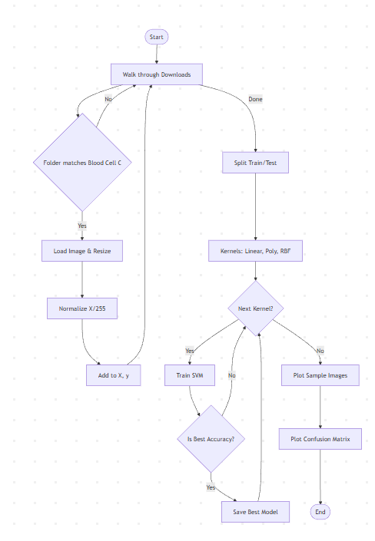
Result:

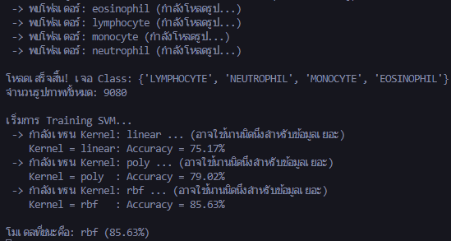

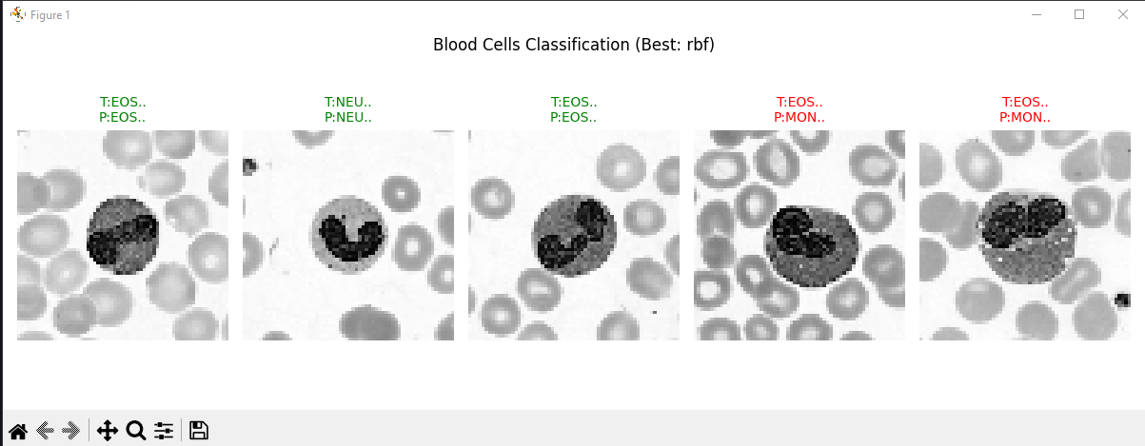

LEB 6: SVM with Smoothed COVID-19 Data CSV (Link).
LINK: https://www.kaggle.com/datasets/hosammhmdali/covid-19-dataset
Objective:
- Apply Support Vector Machines (SVM) to smoothed COVID-19 time-series data and generate short-term forecasts.
Contents:
- Load the smoothed COVID-19 dataset from a .csv file (THA group).
- Split the data into training and testing sets.
- Train SVM models using three kernels: Linear, Polynomial, and RBF.
- Evaluate each model using RMSE and generate a 3-month forecast.
Output:
- RMSE score for each SVM kernel (Linear, Polynomial, RBF).
- Time-series plots comparing Actual values, Smoothed trend, and SVM forecast (3-month horizon), similar in style to the example figure.

import os  import numpy as np  import pandas as pd  import matplotlib.pyplot as plt  from sklearn.svm import SVR  from sklearn.model_selection import train_test_split  from sklearn.preprocessing import StandardScaler  from sklearn.metrics import mean_squared_error  print("1. Configuration & Data Loading...")  downloads_path = r"C:\Users\YH\Downloads"  csv_file_path = None  print(f"Searching for CSV file in {downloads_path}...")  for file in os.listdir(downloads_path):  if "covid" in file.lower() and file.endswith(".csv"):  csv_file_path = os.path.join(downloads_path, file)  print(f" -> Found potential file: {file}")  break  if csv_file_path is None:  print("[Error] No COVID-19 CSV file found in Downloads.")  exit()  print(f"Reading CSV from: {csv_file_path}")  df = pd.read_csv(csv_file_path)  print("Filtering data for Thailand (THA)...")  country = 'Thailand'  df = df[df['location'] == country].copy()  df['date'] = pd.to_datetime(df['date'])  df = df.sort_values('date')  # Use 'new_cases_smoothed' and fill NaN with 0  series = df['new_cases_smoothed'].fillna(0).values  dates = df['date'].values  print("2. Creating Feature from Past (Sliding Window)...")  window = 14 # Look back 14 days  X = []  y = []  # Sliding window creation loop  for i in range(window, len(series)):  X.append(series[i-window:i])  y.append(series[i])  X = np.array(X)  y = np.array(y)  target_dates = dates[window:]  print(f"Total samples created: {len(X)}")  print("3. Splitting Train/Test (Last 90 days for Test)...")  test_horizon = 90 # 3 Months  X_train = X[:-test_horizon]  y_train = y[:-test_horizon]  X_test = X[-test_horizon:]  y_test = y[-test_horizon:]  dates_train = target_dates[:-test_horizon]  dates_test = target_dates[-test_horizon:]  print(f"Train size: {len(X_train)}, Test size: {len(X_test)}")  print("Scaling Features...")  scaler = StandardScaler()  X_train_s = scaler.fit_transform(X_train)  X_test_s = scaler.transform(X_test)  kernels = ['linear', 'poly', 'rbf']  rmse_scores = {}  models = {}  print("4. Training SVR Models (Linear, Poly, RBF)...")  for k in kernels:  print(f" -> Training Kernel: {k} ...")  model = SVR(kernel=k, C=10.0, gamma='scale')  model.fit(X_train_s, y_train)  y_pred = model.predict(X_test_s)  rmse = np.sqrt(mean_squared_error(y_test, y_pred))  print(f" Kernel = {k:<6}: RMSE = {rmse:.2f}")  rmse_scores[k] = rmse  models[k] = model  print("5. 3-Month Forecasting (Recursive)...")  # Use RBF model (usually best) or the best one found  best_model = models['rbf']  last_window = series[-window:].copy()  future_steps = 90 # 90 days ahead  future_preds = []  print("Generating future predictions...")  # Iterate to predict next day, then add prediction to window, slide, and repeat  for _ in range(future_steps):  # Scale current window  x_win = scaler.transform(last_window.reshape(1, -1))  next_val = best_model.predict(x_win)[0]  future_preds.append(next_val)  # Update window: remove first item, add new prediction  last_window = np.roll(last_window, -1)  last_window[-1] = next_val  future_preds = np.array(future_preds)  future_dates = pd.date_range(df['date'].iloc[-1] + pd.Timedelta(days=1), periods=future_steps, freq='D')  print("6. Plotting Results...")  plt.figure(figsize=(12, 6))  # Plot Actual History  plt.plot(dates, series, color='black', label='Actual (Smoothed)')  # Plot Test Interval (Actual)  plt.plot(dates_test, y_test, color='blue', label='Actual (Test)', alpha=0.5)  # Plot Forecast  plt.plot(future_dates, future_preds, color='orange', label='SVR Forecast (Next 3 months)')  plt.title(f'SVR Forecasting of Smoothed COVID-19 Cases - {country}')  plt.xlabel('Date')  plt.ylabel('New Cases (Smoothed)')  plt.legend()  plt.grid(True)  plt.tight_layout()  plt.show()  print("\nResult Summary:")  for k, r in rmse_scores.items():  print(f"Kernel = {k:<6}: RMSE = {r:.2f}") | Flowchart:  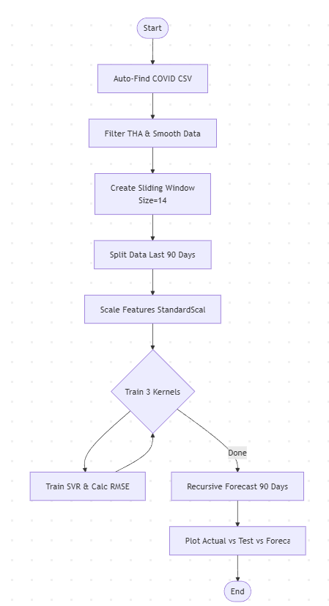
Result:

Kernel = linear: RMSE = 24.34
Kernel = poly : RMSE = 252.62
Kernel = rbf : RMSE = 210.10

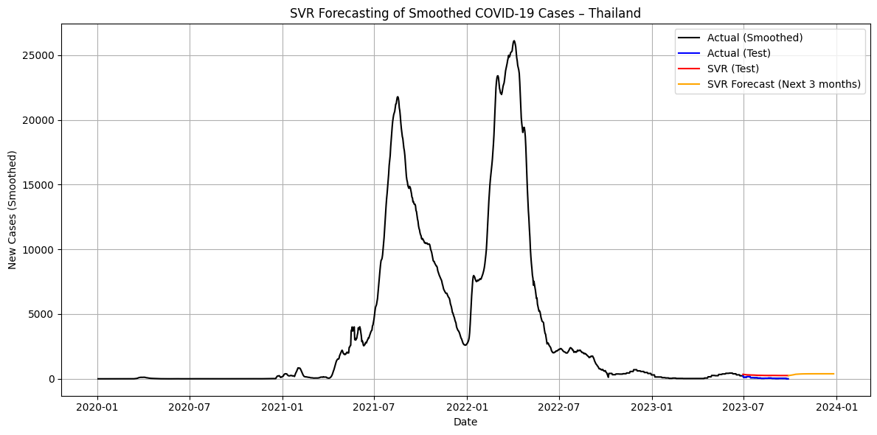
SVR Prediction and 3-Month Forecast of Smoothed COVID-19 Cases – Thailand

